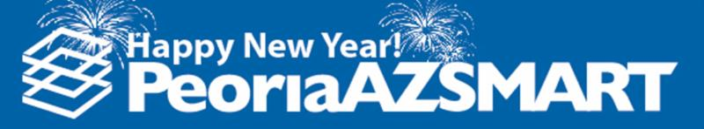

The City of Peoria had a busy 2017. We celebrate the successes of last year as we look forward to a banner 2018, highlighting events and stories that have had an impact on Peoria during the year!

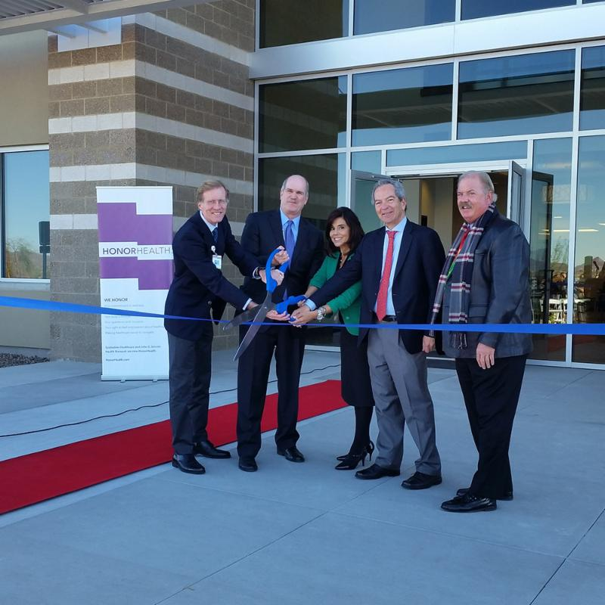 | 

﻿HonorHealth, opened a more than $10 million, 25,000 SF health center at 10230 W. Happy Valley Parkway. This facility brought together primary care physicians, sub-specialists and other healthcare services in one convenient location to serve one of the fastest-growing communities in the valley.

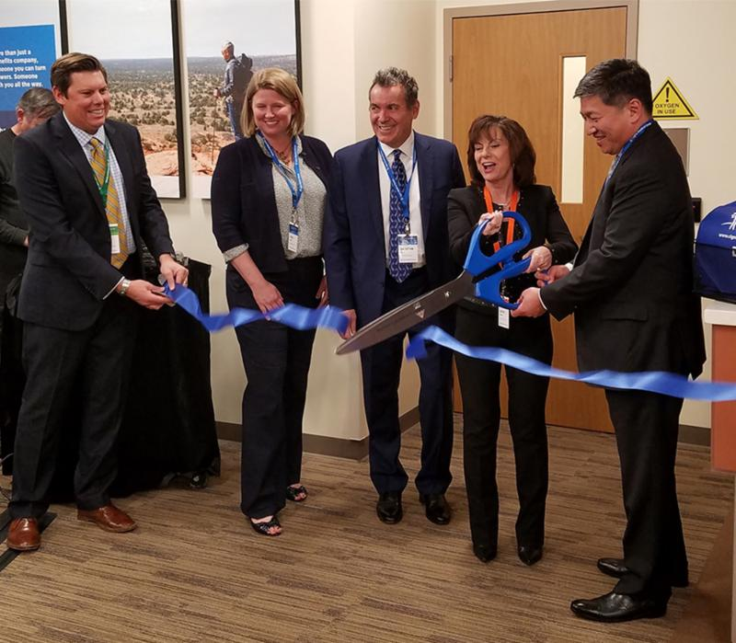

﻿
﻿Cigna Medical Group celebrated the grand opening of its Medical Group Multi-Specialty Center in January. The 60,000 SF, two-story medical office building provides family medicine, internal medicine, pharmacy, digital imaging, laboratory, urgent care and specialty services to patients.

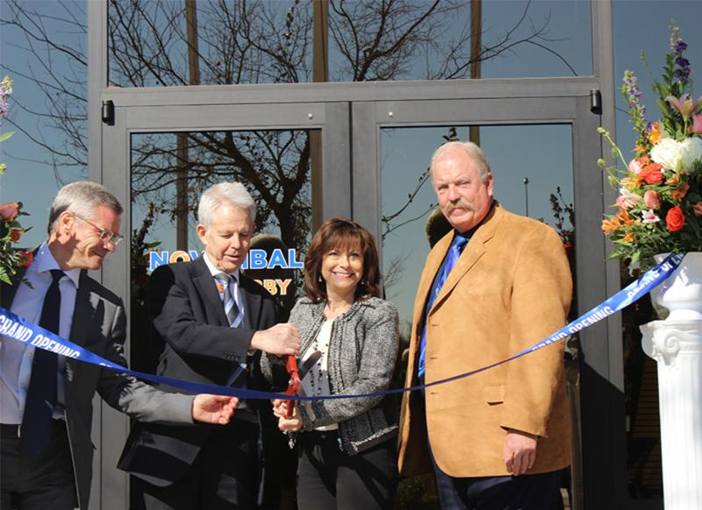

﻿

﻿Novembal held an official open house and ribbon cutting at its new Peoria plant, located along the Loop 101. Novembal produces plastic injected caps and bottle closures mainly for beverage producers.

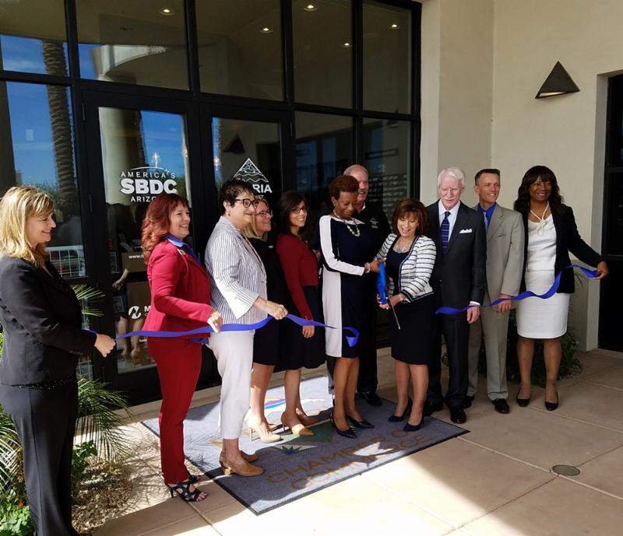

﻿The Arizona Small Business Development Center (AzSBDC) network, in partnership with Maricopa County Community Colleges, celebrated the opening of their new Peoria office in P83 Entertainment District. It offers unique training courses to Peoria businesses and provides onsite one-on-one counseling for business owners, networking opportunities, educational workshops, and virtual counseling.

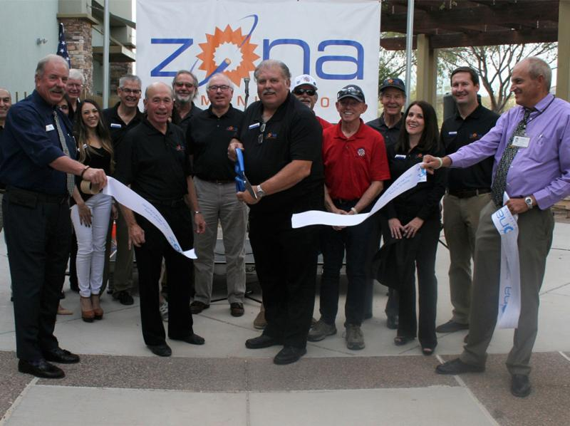

﻿Zona Communications opened their new Peoria headquarters, in November. Zona offers broadband Internet and telephone services to residents and businesses in portions of Peoria, Buckeye, Surprise and northwest Maricopa County.

  ﻿TYR Tactical opened their new 78,000 SF facility in September. This much needed expansion gives TYR Tactical the ability to not only increase production capacity, but also creates hundreds of new jobs.
  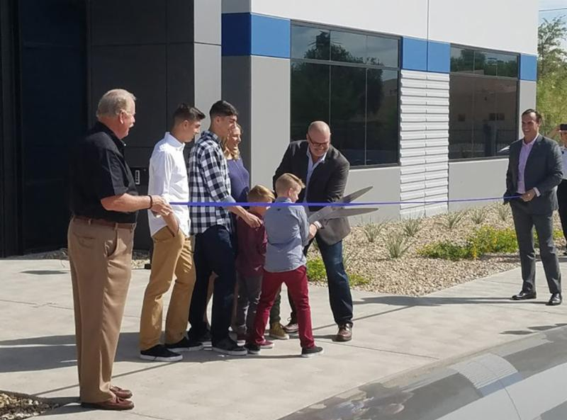

  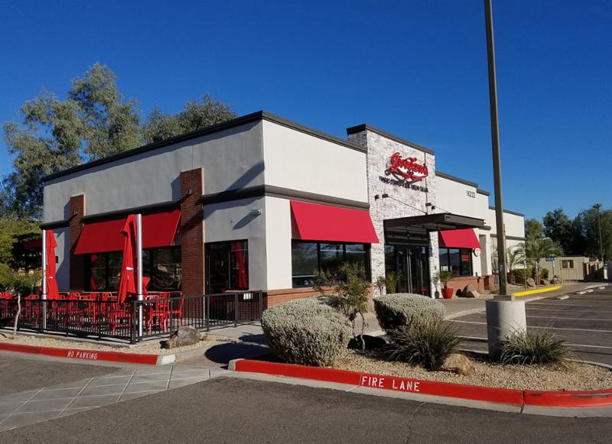
  ﻿
  Giordano’s – The beloved Chicago-based deep-dish pizza shop opened a new location in Peoria in the heart of the P83 Entertainment District.

  Revolu, locally owned, a modern day
  taqueria and bar, opened its doors in the P83 Entertainment District.
  Peoria was also recognized as a national site selection finalist community for both a large insurance services company and for a large advanced manufacturing company. We look forward to another banner 2018 in Peoria, especially as we have multiple premier development sites
  coming online.
  